U-EASY

(USC Easy Access for Students and You)

User Manual

Paraguya, André Paulo O.

Valenzona, Mark Joseph O.

Table of Contents

About U-EASY 3

U-EASY Guide 4

# About U-EASY

Need some help in locating the rooms in USC-TC? How about in knowing the vacancy of a room? Do you need help in knowing the office schedule of a certain office in USC-TC? Then, this is the app for you.

U-EASY is an android app which can locate rooms, offices, facilities. This app also has a Utilization feature in which the user will know the schedule of a room, office, or a facility.

# U-EASY Guide

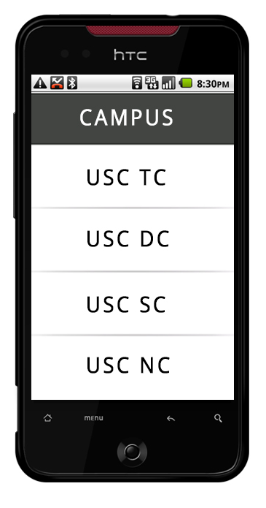

Choose a Campus.

Figure 1. Campus Menu

After choosing a campus

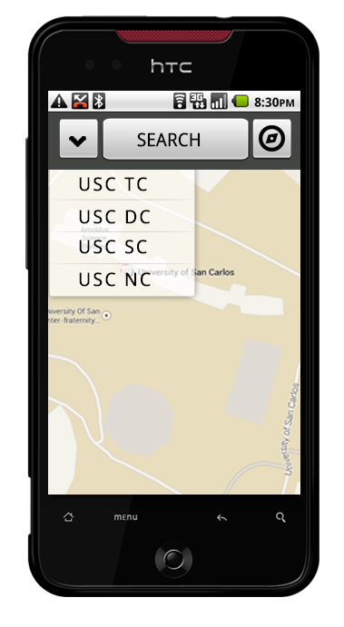

Map Selection

Navigate by Category

Search Button

Navigate using map

Figure 2. Map View

After clicking the Search Button from Map View

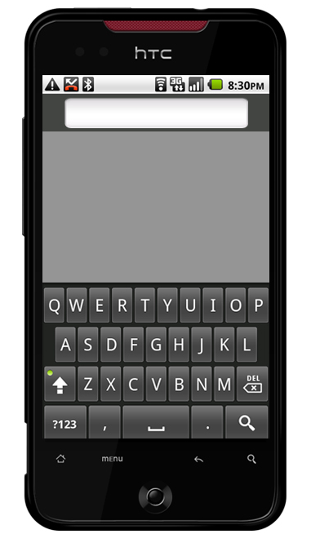

Input Keyword to search

Figure 3.1 Search

After inputting a keyword

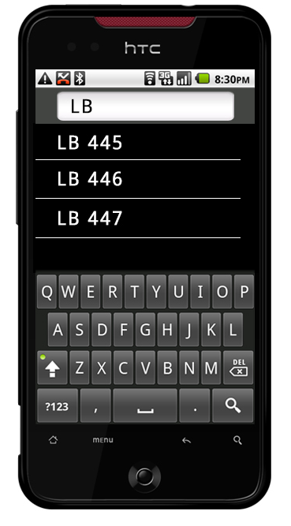

Clickable links of search results

Figure 3.2 Search Results

After clicking a room

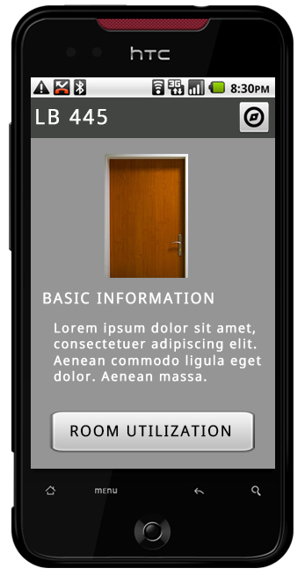

Button leading back to Figure 2 with the room pinned

Room image

Room Basic Information Room Utilization Button

Figure 4.1 Room Info

After clicking Room Utilization

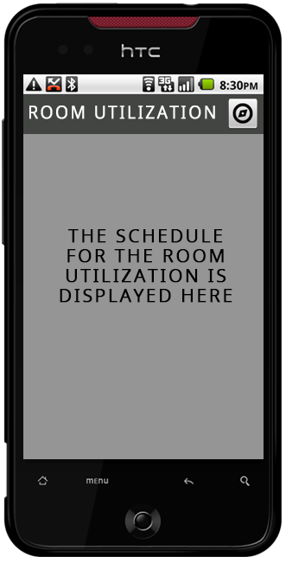

Figure 4.2 Room Utilization

After clicking Explore Icon from Map View

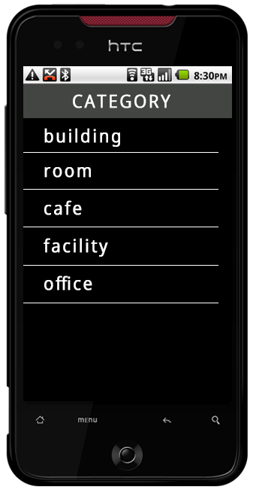

List of Clickable Categories

Figure 5.1 Category View

After clicking a category

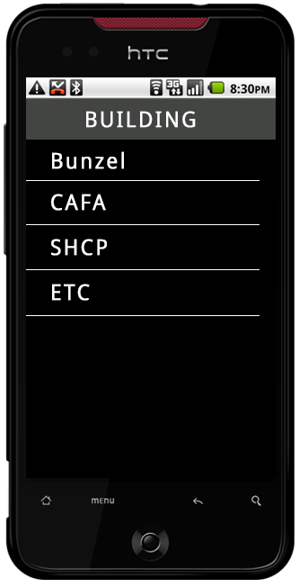

List of links based on the chosen category

Figure 5.2 Chosen Category View

After choosing a building from Figure 5.2 or

navigating the map from Figure 2.

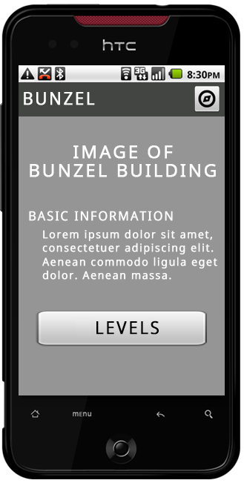

Button to lead back to Figure 2 with this building pinned

Building Image

Building Basic Information

Level/Floor Button

Figure 6.1 Building Info

After clicking Level Button

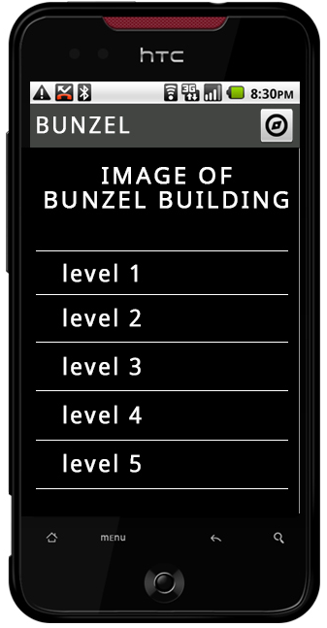

List of Building Floors/Levels

Figure 6.2 Building Level

After clicking a level from Fig 6.2

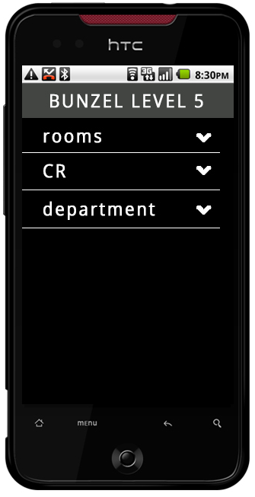

Drop-down Button to show

List of Room Categories the rooms under that category

Figure 6.3 Level Info